**Hans Larson**

**Cover Crop Analysis on the Upper Wapsipinicon Watershed**

**Abstract:**

Every year in the Upper Mississippi Basin, we are losing nutrients in our soil, polluting our streams and rivers, sending our healthy soil down the Mississippi and into the Gulf of Mexico, and increasing flash flood risk. This is largely due to the bare farmland with no vegetation that we leave alone every winter. Whether it is rain or snowmelt, we lose vast amounts of healthy soil every year where there are no living roots holding the soil together. Fortunately, there are several conservation practices and solutions that can reduce soil discharge. One of the most effective of these practices is the use of cover crops. Cover crops are off-season plants like cereal rye, winter wheat, and oats. They are typically planted in the late summer or fall after the primary cash crop is harvested. These plants have long roots that grow deep into the earth, holding the soil and its nutrients together, greatly reducing runoff. Tracking cover crop usage is very important for watershed managers because they can identify exactly which areas are not using cover crops, allowing managers to target areas with incentive to plant. However, this is difficult to track because no dataset exists showing the spatial distribution of cover crop usage. Fortunately, using satellite images in ESRI’s ArcGIS application, we are able to use the Red and Near Infrared (NIR) bands from LandSat imagery to calculate the Normalized Difference Vegetation Index of farmland along with crop rotation history. With this information, I was able to determine whether or not a given parcel of crop land has used cover crops. This project focuses on automating the process of selecting cover crop fields by using ModelBuilder in ArcGIS.

**Introduction**

Cover crops are an effective conservation strategy for both water quality improvements and flood reduction. Very few producers used cover crops in Iowa prior to 2009, but usage has increased steadily since then thanks in part to the beginning of the Iowa Nutrient Reduction Strategy beginning in 2012. The latest progress report for the Iowa Nutrient Reduction Strategy in 2017 estimates there are approximately 760,000 acres of cover crops in Iowa.

Not only does it affect our streams, but soil runoff carries into larger watersheds like the Mississippi River, eventually pouring loads of nitrogen and phosphorus into the Gulf of Mexico, damaging environments and habitats along the way. 39 percent of these total pollutants come from corn and soybean fields from the Upper Mississippi sub-basin, which the Upper Wapsipinicon River is a tributary of. Fortunately, there are many conservation practices and solutions that can effectively reduce pollutant discharge from agricultural fields. One of the most effective practices is the use of cover crops.

Cover crops are off-season plants like cereal rye, winter wheat, oats, clovers, or brassicas. They are typically planted in late summer or fall into agricultural fields with corn or soybeans to provide cover after the primary cash crop is harvested. They grow late into the fall, effectively protecting the soil during the late fall, winter, and spring months, when there are usually no other living plants on agricultural fields. Research by groups like Practical Farmers of Iowa and Iowa State University has shown that cover crops are one of the most effective practices for improving soil health and reducing runoff.

Cover crop usage is difficult to track because of the variability of use from year to year. No data set exists showing the spatial distribution of cover crop usage in Iowa each year. However, given that cover crops are such an important conservation tool for reducing flooding and improving water quality, it is important for watershed managers to understand where cover crops are being used. In the past, the only way to estimate something as variable as cover crops for a given area was to conduct what conservation professionals call a “windshield survey”. A windshield survey is when a conservation professional actually drives around and records what they can observe from their vehicle. Today, conservation professionals have aerial photography, computer programs, GIS tools and other modern methods of accurately estimating the number of acres and spatial distribution of cover crops across a relatively large watershed like the UWR.

**Cover Crop Analysis on the Upper Wapsipinicon River Basin**

This project is based on a project that I worked on at my previous internship at Northeast Iowa Resource Conservation and Development. The Upper Wapsipinicon River is one of many smaller tributaries of the Upper Mississippi River. The area surrounding this watershed is made up of mostly agricultural land, and is thus an area where conservation practices like using cover crops are very important to the health of surrounding watersheds. The purpose of this study was to efficiently locate areas of agricultural land that appeared to have cover crops in the winter of 2016-17 and to analyze the percentage of cover crop fields among agricultural land. This allowed us to see where cover cropping is more prominent in the Upper Wapsipinicon watershed, and gave us important information on which areas needed more incentive to plant cover crops. Analysis of cover crop locations along the Upper Wapsipinicon looks at the smaller, 12-digit Hydrologic Unit Code (HUC) tributaries of the Upper Wapsipinicon and their surrounding farmland that encompass the 8-digit HUC Upper Wapsipinicon River.

**Previous Methods**

To effectively and efficiently determine which areas may have had cover crops, I implemented a method used by the Environmental Working Group and the Practical Farmers of Iowa. Using ArcGIS software, and the Near Infrared (NIR) and Red bands from Landsat 8 satellite imagery in the spring months of 2017 before the planting of corn or soybeans, I could calculate the Normalized Difference Vegetation Index (NDVI) value of every pixel of a Landsat image over the Upper Wapsipinicon. This NDVI value is a number between -1 and 1 that can detect what kind of land cover exists at any given pixel of an image.

Looking only at agricultural land, I displayed every agricultural parcel in a new layer in ArcMap according to these NDVI value standards:

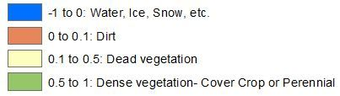

Using these standards, along with the crop rotation history of the parcel, I was able to determine that if a parcel of land showed green (NDVI value of above 0.5) for the spring months of 2017, the farmer may have used a cover crop in the offseason. Aerial Imagery by county and crop rotation history was used to confirm these assumptions. For example, if land that was detected as dense vegetation had forest, perennial crops, or anything other than corn or soybeans in the previous year's crop history, it was assumed that cover crops were not planted in the previous fall, and the land already had vegetation in the off-season. I then created a new polygon layer in ArcGIS for all areas that appeared to use cover crops for further analysis.

**New Method - ModelBuilder**

Because this method was very time-consuming, I thought it would be beneficial to Northeast Iowa RC&D to automate this process. In ArcMap, I have the ability to create tools with ModelBuilder, a program within ArcMap that allows you to string together multiple tools to create your own. By using ModelBuilder, I was able to use various tools, mainly the “Raster to Polygon” tool, to automatically create new polygon shape files for each area with an NDVI value equal to that of dense vegetation:

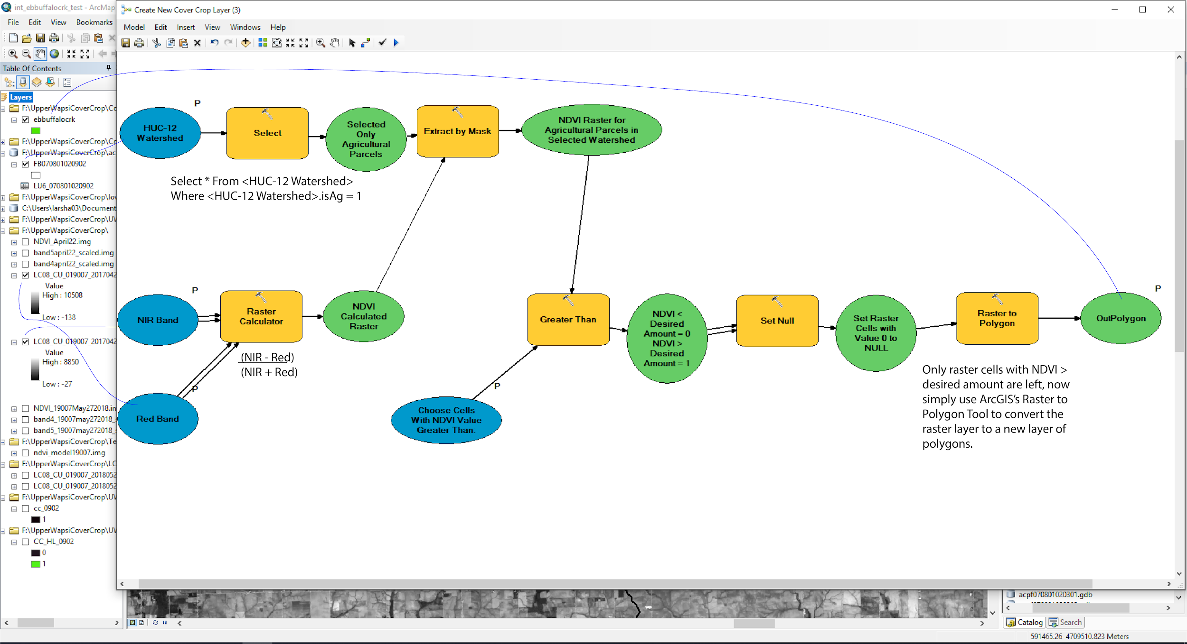

Here is an example of a HUC-8 watershed, East Buffalo Creek, after the first process:

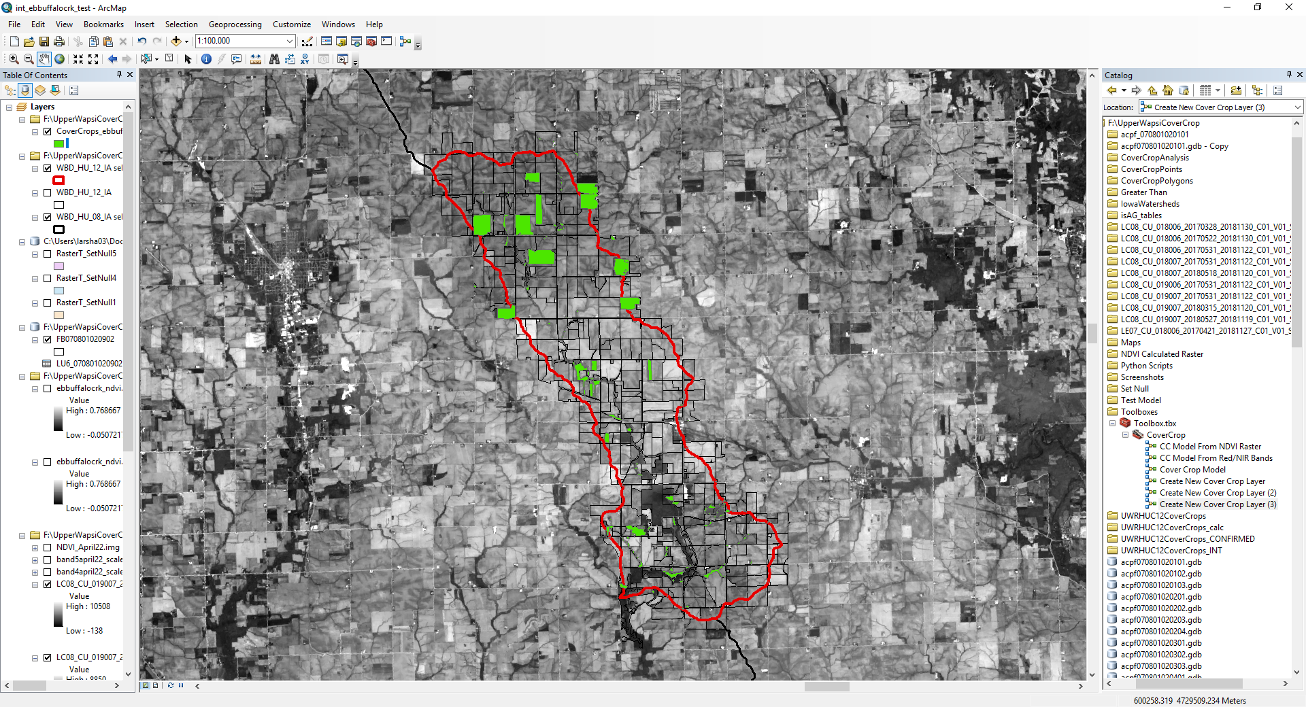

After running the tool on this watershed, agricultural areas that had dense vegetation in the spring months were added as a new shape file. However, there are some more questions to consider. These areas may be agricultural, but they might be perennial farms that have vegetation in the spring whether they use cover crops or not. The tool could also be identifying shelter belts that contain trees and are not used for crops, or small patches of trees spread around the area. To avoid this, I ran the new shape file through another tool that narrows the data down to land that had planted either corn or soybeans in the last year. It also allows the user to select the minimum area requirement to avoid collecting small shelter belts and trees as cover crop fields. In this example, I got rid of all areas less than 20,000 square feet using this tool workflow in ModelBuilder:

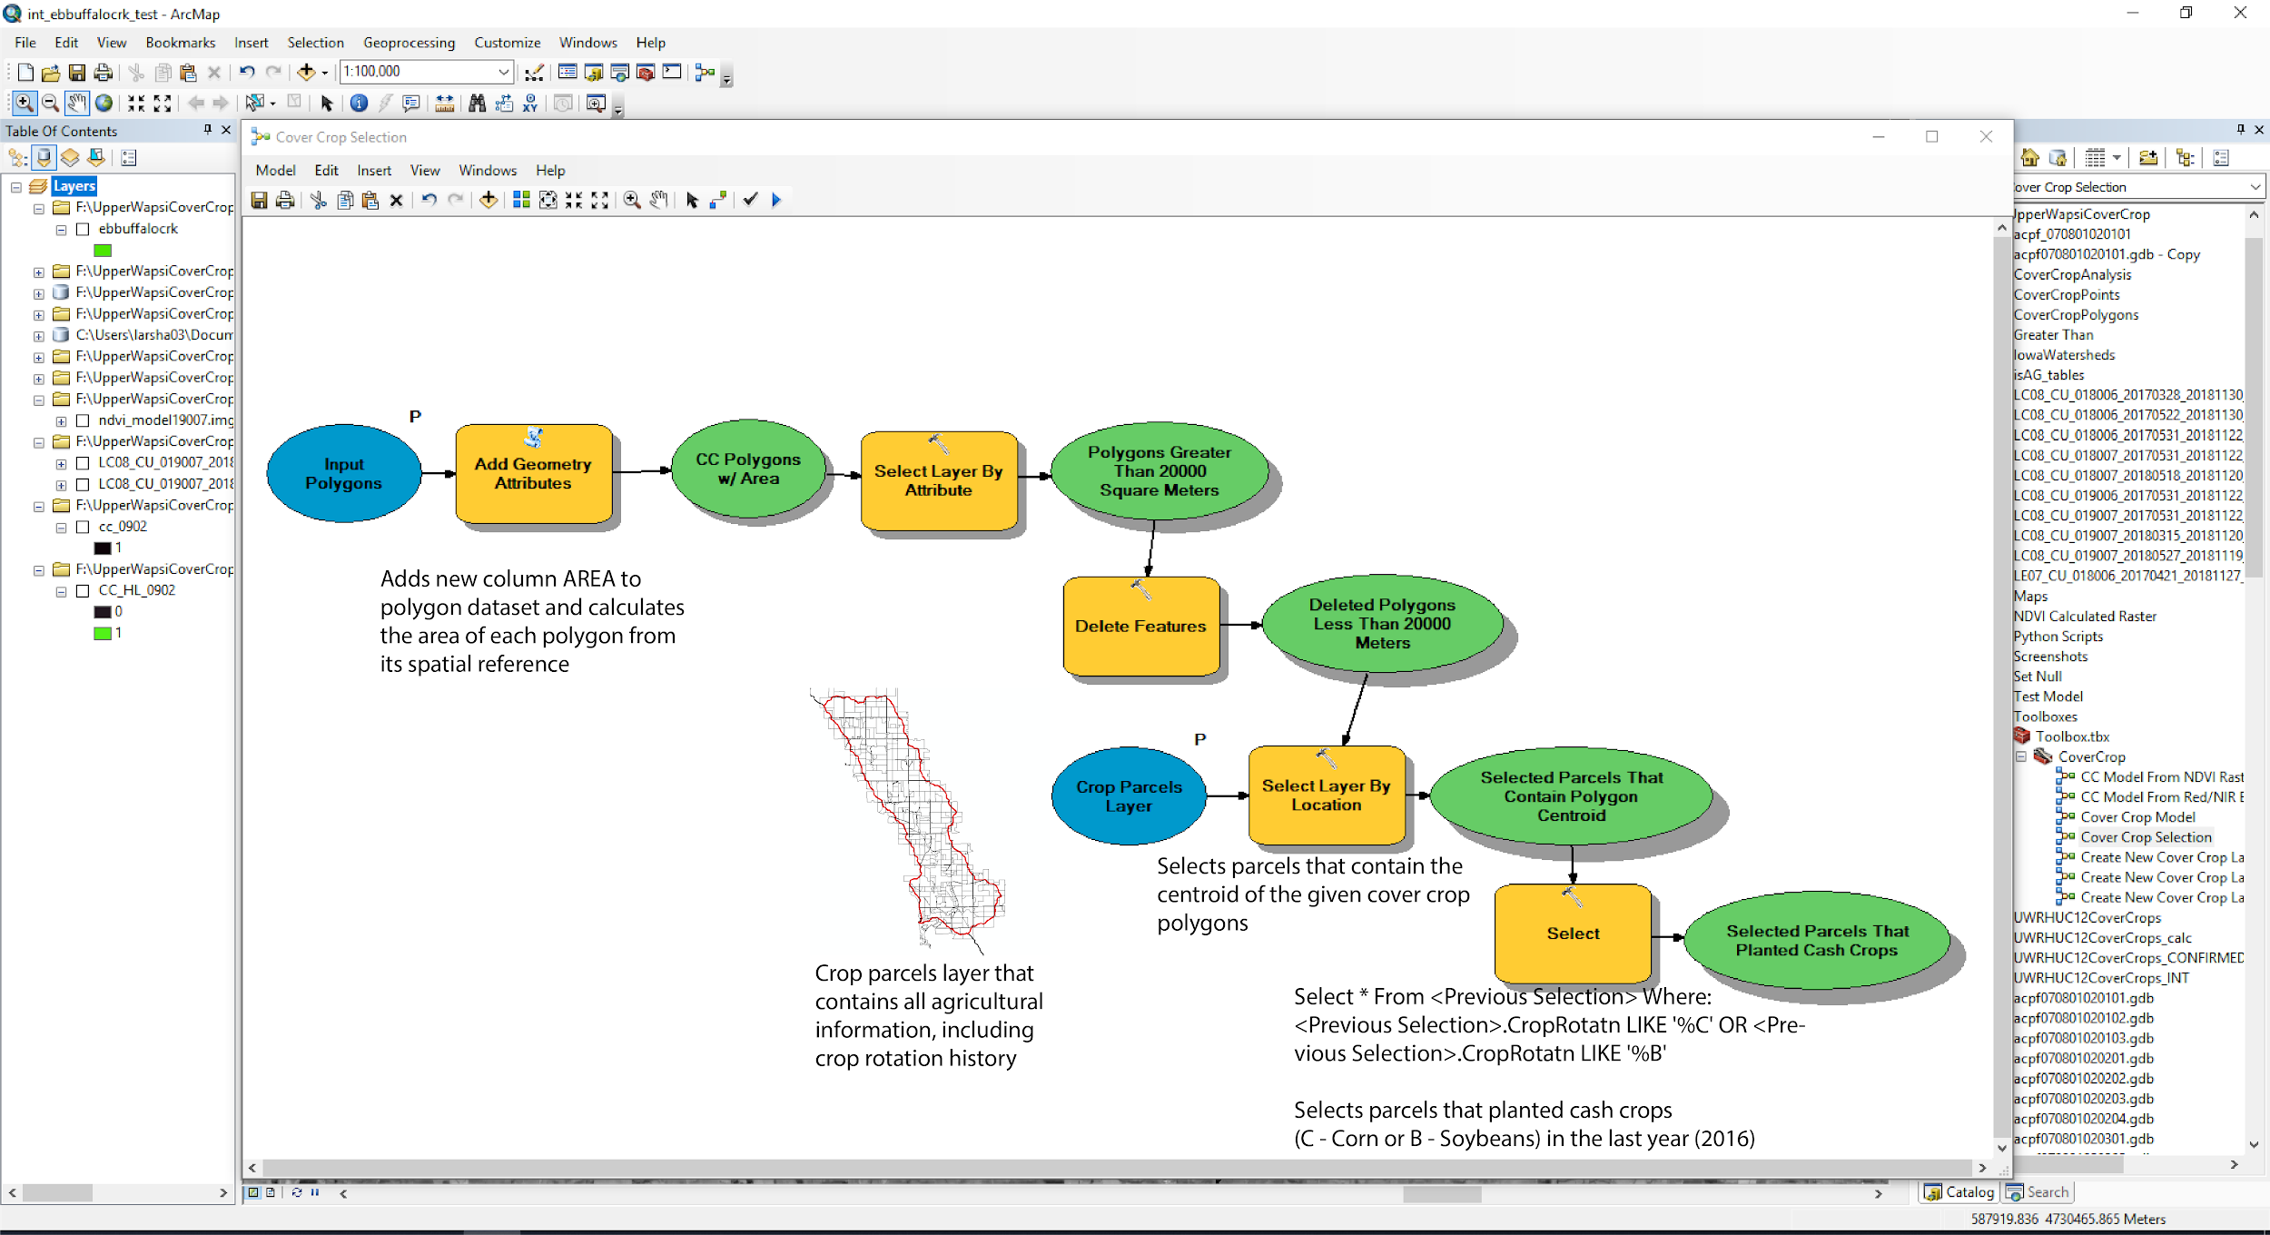

This process resulted in narrowing down the features to what can be seen here, compared with the results of the manual process for the same watershed that I completed as an intern at RC&D:

**ModelBuilder Method:**

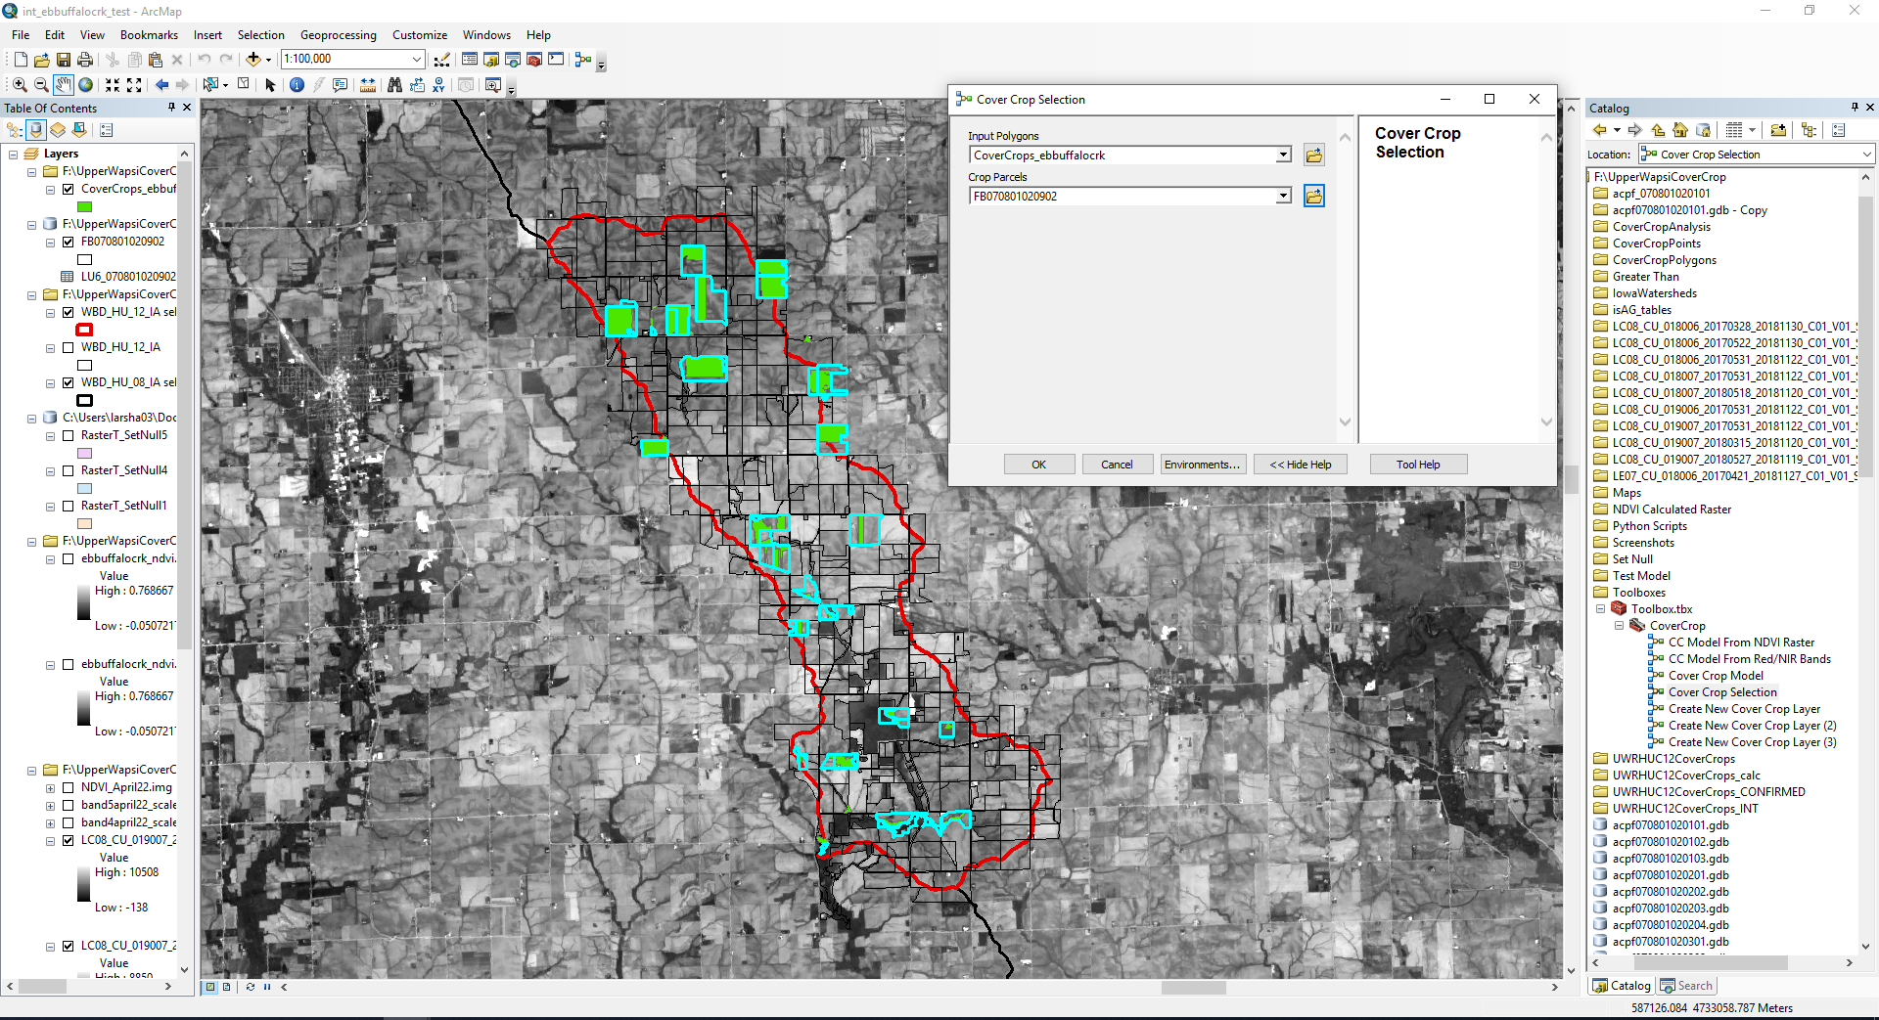

**Manual Method** 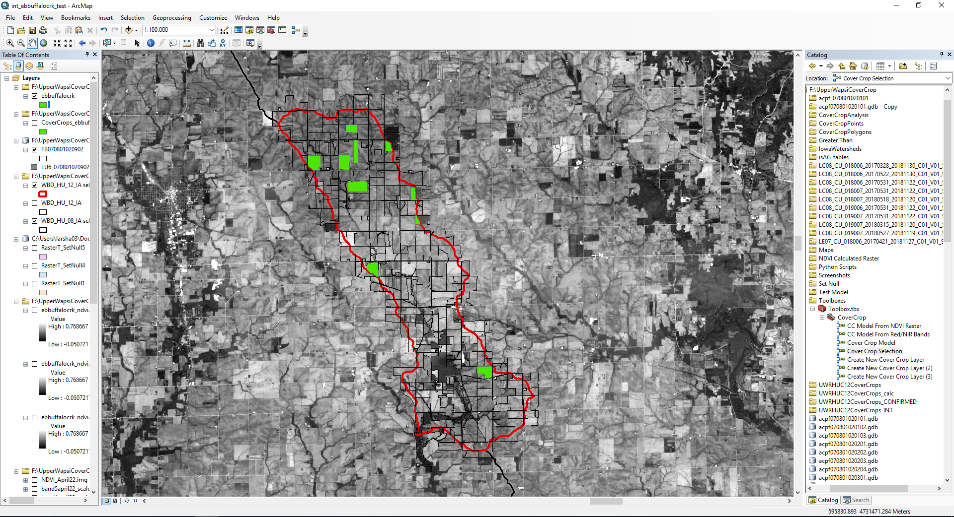

**Conclusion**

As you can see, the results are strikingly similar. Almost identical results were obtained, but the automated process took a fraction of the time that the manual method I completed as an intern did. The tool has proven to be successful, and can easily take two satellite images and locate parcels of land that have used cover crops. This could be used as an important tool for watershed management authorities to quickly locate areas that use cover crops.